Module Name: STUDENT RECORDS MANAGEMENT
Test Case ID: TC_001
Application / Tool: Student Management System (Eclipse IDE / Java Application)
Scenario ID: 1A
Scenario: SIGN UP / ADD STUDENT WITH VALID ID, NAME AND COURSE
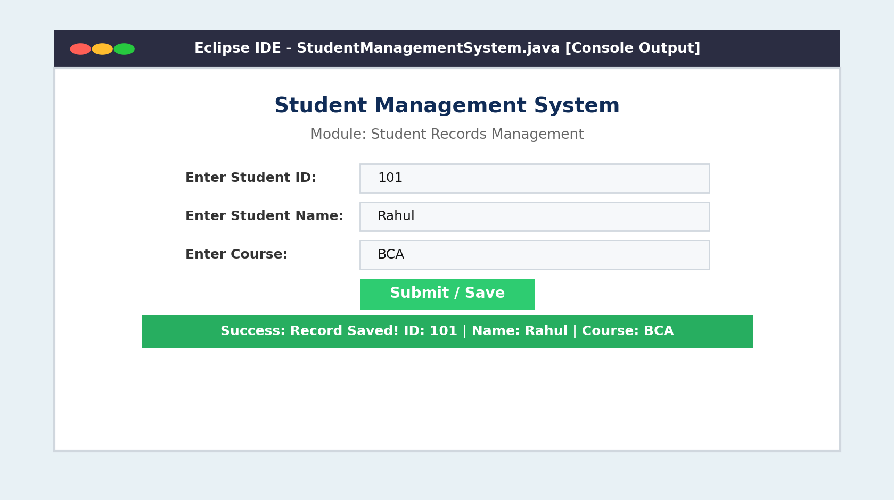
Scenario ID: 2A
Scenario: SIGN UP / ADD STUDENT WITH INVALID ID AND VALID NAME
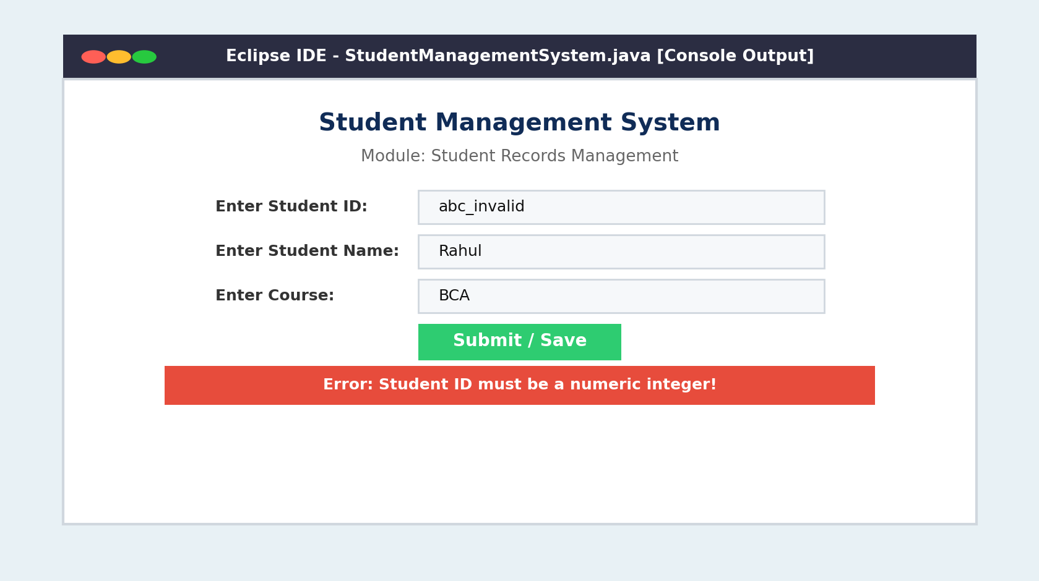
Scenario ID: 3A
Scenario: SIGN UP / ADD STUDENT WITH VALID ID AND EMPTY NAME
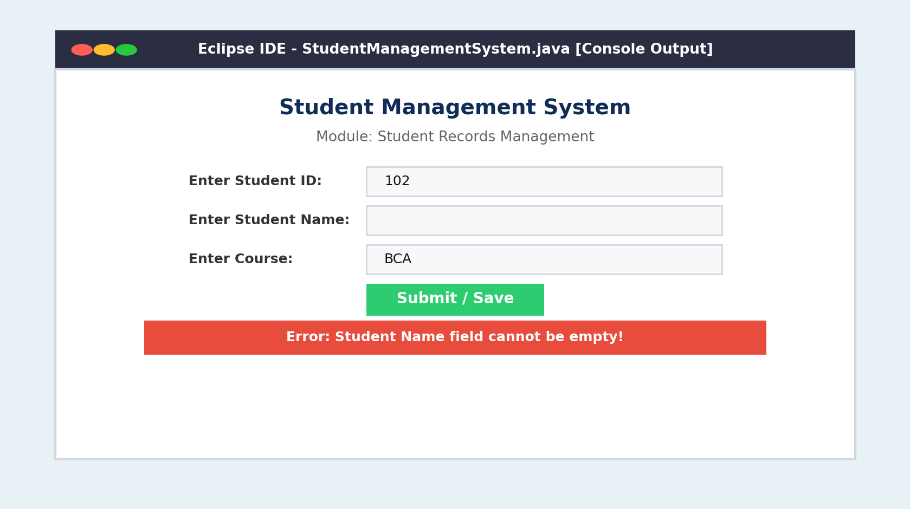
Scenario ID: 4A
Scenario: SIGN UP / ADD STUDENT WITH EMPTY ID AND VALID NAME
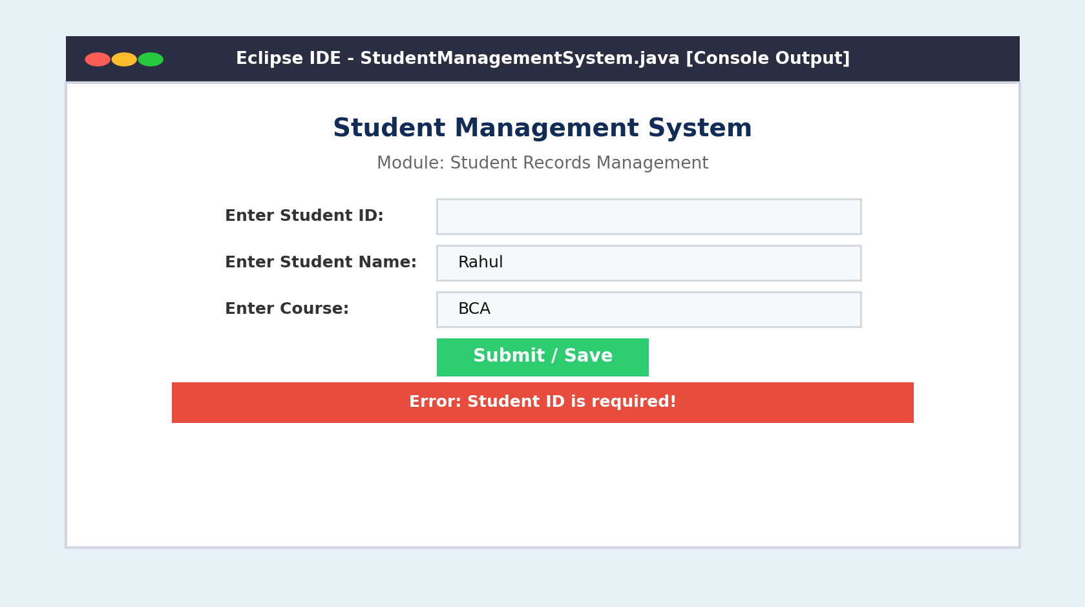
Scenario ID: 5A
Scenario: SIGN UP / ADD STUDENT WITH EMPTY COURSE
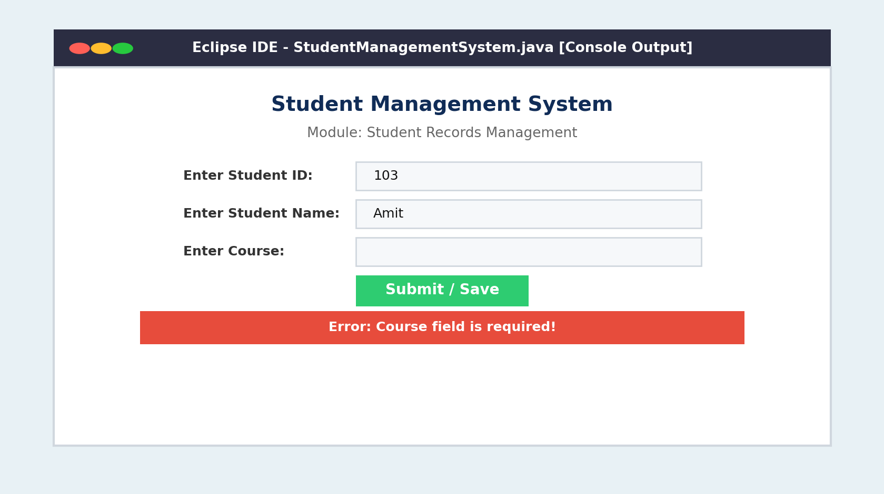
Scenario ID: 6A
Scenario: SIGN UP / ADD STUDENT WITH ALL FIELDS EMPTY
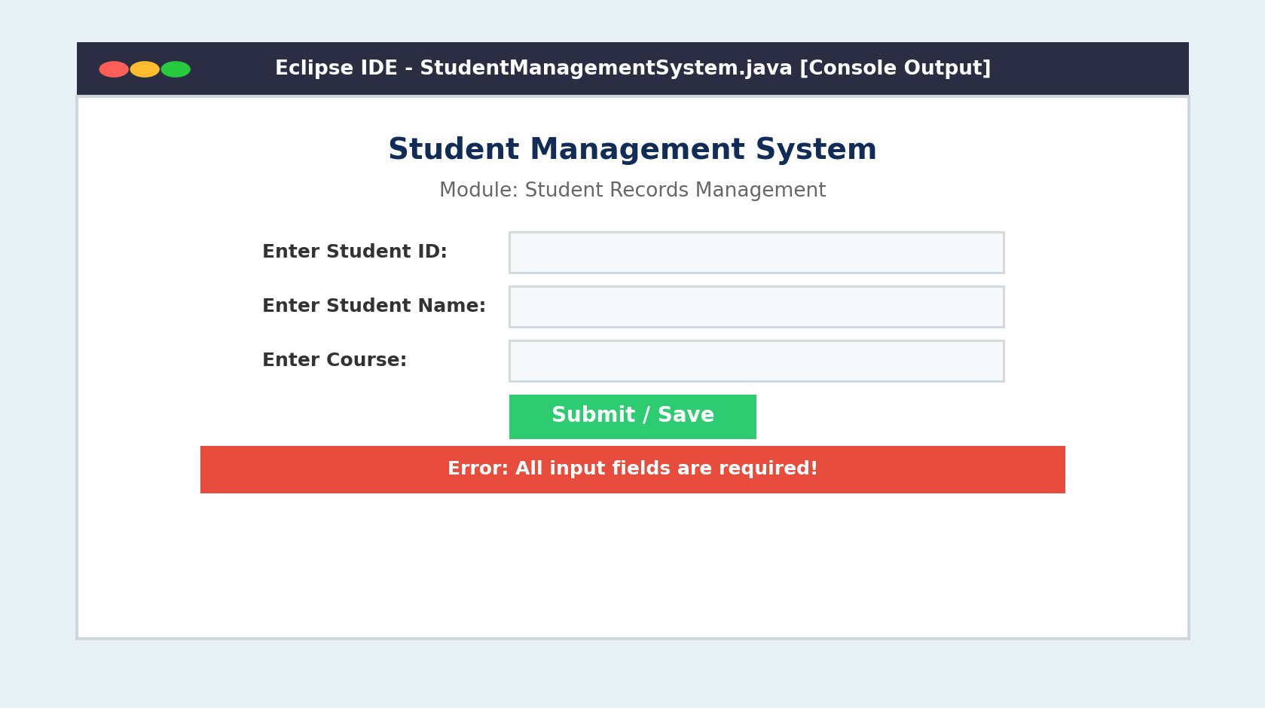
Scenario ID: 7A
Scenario: VIEW / DISPLAY STUDENT RECORD DETAILS
